Start a Call from a Chat in Teams
You can make one-on-one or group calls with anyone in your organization directly from a chat without having to host a team meeting. These calls are private and won't appear in any team conversation. Entries for the calls will appear in your chat, though.
1. Go to your chat list, and click New chat to start a new conversation.
2. Choose this icon to start a New chat

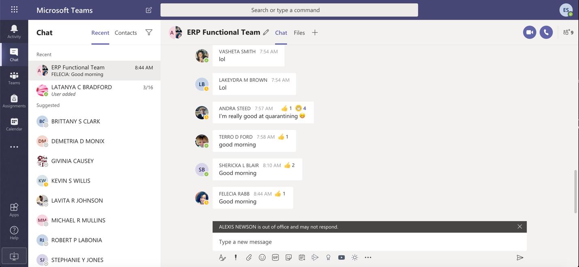
2. Type the name or names into the To field at the top of your new chat.
3. Then click Video call or Audio call to start a call.
4. Up to 50 people can be on the same video call.

2-minute video tutorial – Start a Call from a Chat in Teams
https://support.office.com/en-us/article/start-chats-and-make-calls-a864b052-5e4b-4ccf-b046-2e26f40e21b5

Use Controls within a Call

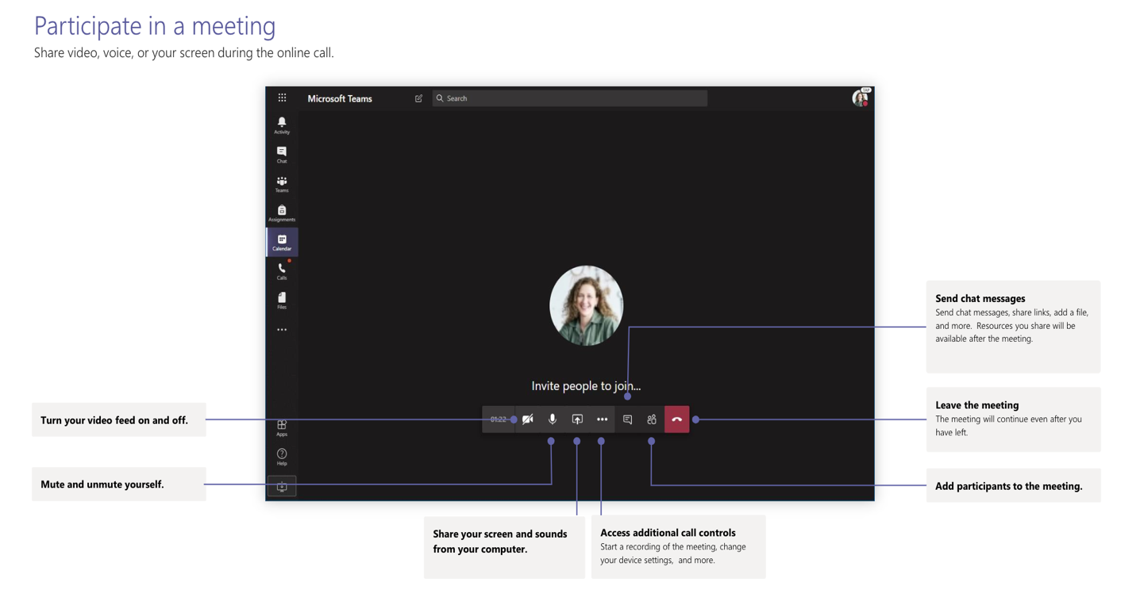

Show Your Screen During a Call
In Microsoft Teams, you can show your desktop, a specific app, presentation, or any file while in a meeting.
1. Select Share .
2. Select what you want to share:
3. Desktop lets you show everything on your screen.
4. Window lets you show a specific app.
5. PowerPoint lets you show a presentation.
6. Browse lets you find the file you want to show.
7. After you select what you want to show, a red border surrounds what you're sharing.
8. Select Stop sharing to stop showing your screen.

1-minute video tutorial and steps – Show your screen during a meeting
https://support.office.com/en-us/article/show-your-screen-during-a-meeting-90c84e5a-b6fe-4ed4-9687-5923d230d3a7

Share Your PowerPoint During a Call

If you're a presenter
1. Select Share.
2. Choose a presentation under the PowerPoint category.

If you're a meeting participant
1. Select Navigate forward to move forward in a presentation without interrupting the presenter.
Note: The presenter must share the file from the PowerPoint category in order for participants to skip around during a presentation.
2. Select To presenter to sync your view back to the presenter's when you want.

1-minute video tutorial and steps – Share your PowerPoint
https://support.office.com/en-us/article/tip-show-powerpoint-slides-in-a-meeting-ddfc73dd-b957-4f2b-8e42-ce078f51873c

